WINE FUNDRAISER



**Australian Kodokan Judo Association WINE FUNDRAISER**

**The Australian Kodokan Judo Association** was founded in 1981 by Mr Ivan Zavetchanos, one of Australian Judo’s most illustrious icons. The Kodokan Association’s principal charter is to preserve the original doctrines of Judo, as espoused by Judo’s founder Dr Jigoro Kano.

The heart and soul of Judo, in the opinion of the Australian Kodokan Judo Association, is in mainstream grassroots judo clubs across the country who cater to juniors, young adults, senior players and veterans who support and applaud the sporting and competitive facets of judo but do it themselves as a complete personal development system possibly for the whole of their lives, not just as young Olympic hopefuls or elite athletes. To this end, the AKJA’s resources are devoted to the development of judo in its entirety, with no special emphasis on the elite or the political desirability of developing international competitors.

This year The Australian Kodokan Judo Association national championships are being held early in October in Melbourne, facilitated by the **Victorian Amateur Judo Union**. The history of the V.A.J.U. began in 1952 in Brunswick, Victoria and the V.A.J.U. was a foundation member of the J.F.A. The V.A.J.U. was instrumental in getting Judo recognized by the Australian Olympic Federation. In 1981 the V.A.J.U. organized the formation of the Australian Kodokan Judo Association (A.K.J.A.), which expanded very rapidly into all States of Australia and has conducted a National Judo championship annually ever since, plus sundry international events. To commemorate the national championships the V.A.J.U. are running a fundraiser so they can continue their good work in promoting the safe and fun pursuit of Kodokan Judo in Victoria.

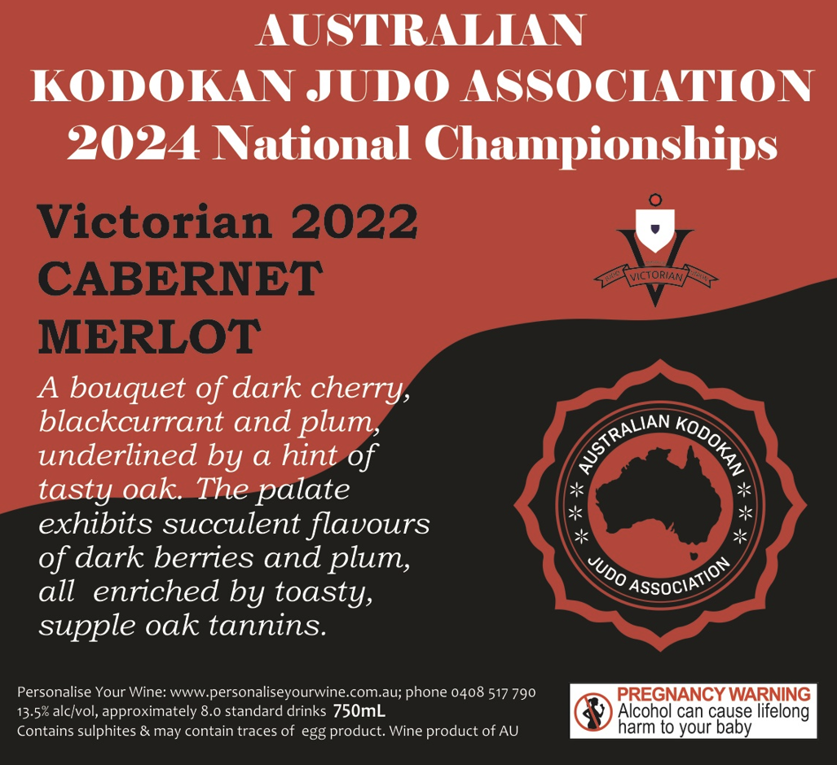

Most people we know enjoy a nice glass of wine! Ask your family, friends, and work colleagues if they would also like to buy some quality wine and support the V.A.J.U. Wine also makes an excellent gift for birthdays and other special occasions, and it’s always handy to have a few extra bottles around to save a trip to the Bottle-O.

Each bottle has an attractive label showcasing the national event. The minimum order is 6 bottles, and you can mix and match as you see fit. You will receive a 10% discount if you order a box of 12. The wines can also be sent as a gift to someone – just select ‘Send this order to someone else’ at the checkout and include your greeting in the comments section.

All Melbourne metro & Mornington Peninsula are FREE delivery. For all VIC regional orders freight will be calculated at the checkout. For any orders outside of VIC please email or call for a quote on freight before placing your order.

Orders can be placed directly online at the below link –

<https://www.personaliseyourwine.com.au/shop/current-fundraisers/australian-kodokan-judo-association>

Use promo code ‘AKJA12’ in the online cart just before you checkout or use the second column on the paper-based order form for your discount on 12 or more bottles.

Alternatively, please complete the below order form and email a copy through to Darren O’Hara at [darren@personaliseyourwine.com.au](mailto:darren@personaliseyourwine.com.au).

In anticipation of a successful fundraising drive, we thank you for your support.

**Australian Kodokan Judo Association WINE FUNDRAISER Order Form**

To assist in packing and distribution please ensure that your order form is completed in full and clearly legible.

|  |  |  |  |  |  |  |
| --- | --- | --- | --- | --- | --- | --- |
| * **The minimum order is 6 bottles in total and can be a mixed selection.** * **FREE Melb metro delivery to your door or see below for freight rates.** * **If ordering 12 or more bottles use the pricing the second column which is inclusive of a 5% discount on a mixed 12-bottle purchase.** | | | **Bottle Price** | **Price in a mixed 12 bottle buy** | **No. of**  **Bottles** | **Total $** |
| **S113 VICTORIAN PROSECCO**  Vibrant aromas of citrus, apple, and pear lead to a fresh, crisp palate with clean delicate bubbles. Finishes off both light and refreshing, leaving you wanting more. A fine example of Prosecco and true to its ancestral style in northern Italy. A great party starter! | | | $20.00 | $18.00 |  | $ |
| **W104 VICTORIAN SAUVIGNON BLANC 2022**  The fruit for this Savvy was harvested in the cool of night to obtain a variety of fruit flavours. Inviting zesty citrus and passionfruit aromas. The palate is bursting with even more vibrant flavours of gooseberry and tropical fruit and finishes with a refreshing crispness. | | | $20.00 | $18.00 |  | $ |
| **W127 VICTORIAN PINOT GRIGIO 2023**  A youthful pale straw in colour. Aromas of nashi pear, lemon and blood orange. Refreshing pear and citrus on the palate followed by a crisp line of minerality on the finish. A very versatile food friendly wine. | | | $20.00 | $18.00 |  | $ |
| **R173 VICTORIAN SHIRAZ SANGIOVESE ROSE 2023**  Made from a luscious blend of Shiraz and Sangiovese grapes, this rosé has the best of both worlds and isn’t afraid to show it. Delicious flavours of strawberries and cream, balanced by a zesty acidity and gorgeous length make this wine blossom before you! | | | $20.00 | $18.00 |  | $ |
| **R122 VICTORIAN PINOT NOIR 2023 (Limited - Yarra Valley)**  Australia’s best Pinot Noir wines come from cool climates and this one is a stunning example. It has dense colours and an attractive nose of red berries with a firm mid palate of fresh cherry and plum. An elegant well-structured wine with a silky-smooth finish. | | | $20.00 | $18.00 |  | **$** |
| **R122 VICTORIAN SHIRAZ 2023**  Mulberry and cherry aromas with underlying spicy vanillin oak. On the palate juicy dark berries with subtle toasty oak and soft, smooth tannins. A lighter style fruit driven Shiraz ideal for BBQ dishes and everyday drinking. | | | $20.00 | $18.00 |  | **$** |
| **R166 VICTORIAN CABERNET MERLOT 2022**  A bouquet of dark cherry, blackcurrant and plum, underlined by a hint of tasty oak. The palate exhibits succulent flavours of dark berries and plum, all enriched by toasty, supple oak tannins. | | | $20.00 | $18.00 |  | **$** |
| **DELIVERY FEE**  The minimum order for delivery is 6 x bottles. Melbourne metro & Mornington Peninsula free delivery. Freight for VIC regional is as follows: 6-12 bots $15.00, 13-24 bots $30.00, 25-36 bots $45.00…….and so on. For any orders outside of VIC please phone first for a quote. | | |  |  |  | **$** |
| Payment details:  🞏 Credit Card  🞏 Cheque (must be payable to Personalise Your Wine)  🞏 EFT (payment to Personalise Your Wine, BSB 063-155 Acct no 1029 4439) | | | **TOTAL** |  |  | **$** |
|  |  | 🞏 **YES**, I would like to be included on your mailing list | | | | |

**Credit card details:**

Name on card: ______________________________________________________________________ Card type: Visa / MasterCard

Card no.: ______________________________________________________________________________Expiry date: _____/_____ CVV: ________

I authorize Personalise Your Wine to charge the above amount to my credit card. Signed: ______________________________ Date: ___ /___ /___

**Delivery order form to Personalise Your Wine**

Please accept my order for the following Australian Kodokan Judo Association wines.

I declare that I am over 18 years of age and agree with the following conditions:

1. That I am placing an order on Personalise Your Wine, holder of Victorian Packaged Liquor Licence No 36128911.

2. No obligation to sell or supply the goods will arise until the order is received and accepted at the licensed premises.

3. The applicable law for transactions for the purchase of wine from Personalise Your Wine is the law of the State of Victoria.

4. By placing an order with Personalise Your Wine I accept that the ownership of and risk to the goods passes to the customer upon payment for the goods and when the goods have been picked up by the customer from Personalise Your Wine or delivered to the nominated address.

5. If a wine/s is not available, we reserve the right to make a substitution of another wine of equal or greater quality and price.

Name: ___________________________________________ Telephone: _____________________ Email: _________________________________________

Address: __________________________________________________________________________________ _____________________Postcode: __________

Signed: ____________________________ Delivery instructions: _____________________________________________________________________________